Project Design Phase-II
Data Flow Diagram & User Stories

Date | 28 september 2026
Team ID | SWTID-2026-1668
Project Name | Streamlining IT Procurement: Automating Standard Laptop Orders With Flow Designer.
Maximum Marks | 4 Marks

Data Flow Diagrams:
A Data Flow Diagram (DFD) is a traditional visual representation of the information flows within a system. A neat and clear DFD can depict the right amount of the system requirement graphically. It shows how data enters and leaves the system, what changes the information, and where data is stored.

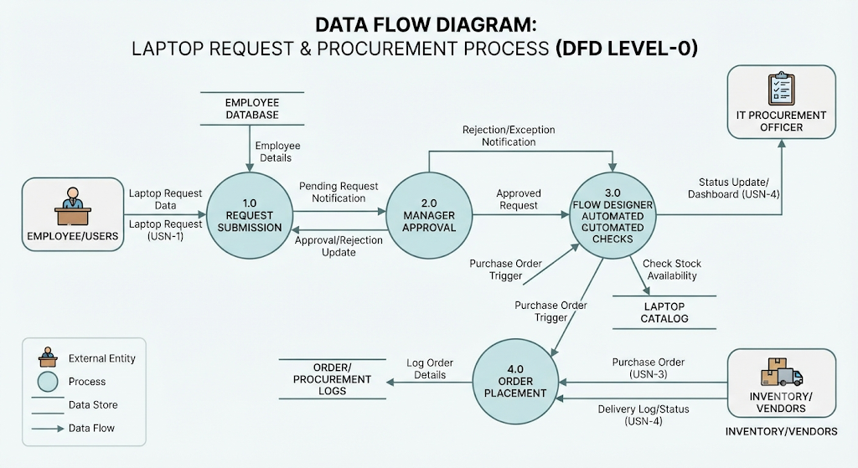
Example: DFD Level 0 (Industry Standard)
